Measures of Dispersions:

Dispersion refers to the spread or variability in the data.
If the dispersion is small, it indicates high uniformity of the observations in the distribution. Absence of dispersion in the data indicates perfect uniformity. This situation arises when all observations in the distribution are identical.

Purposes of measures of dispersions:
First, it is one of the most important quantities used to characterize a frequency distribution.
Second, it affords a basis of comparison between two or more frequency distributions.

Measures of dispersion include the following: range, mean deviation, variance, and standard deviation.

Range: The simplest measure of dispersion is the range. It is the difference between the largest and the smallest values in a data set.
Range = Largest value – Smallest value
Let 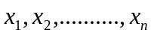 are the values of observations in a sample, then range (R) of the variable X is given by:
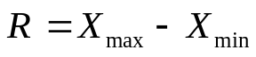

Merits and limitations: Among all the methods of studying variation, range is the simplest to understand and the easiest to compute.
Range cannot tell us anything about the character of the distribution within two extreme observations.

Mean Deviation: The arithmetic mean of the absolute values of the deviations from the arithmetic mean.i.e.mean deviation is obtained by calculating the absolute deviations of each observation from mean and then averaging these deviations by taking arithmetic mean.

Mean deviation for ungroup data:

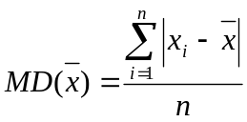
Example: The weights of a sample of crates containing books for the bookstore (in pounds) are:
103, 97, 101, 106, 103
Find the mean deviation.
Sol:
=102
The mean deviation is:
=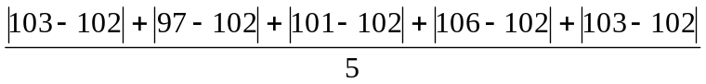
=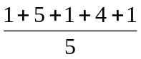
=2.4

Merits and limitations: The advantage of the mean deviation is its relative simplicity and it is less affected by the values of extreme observation.
The greatest limitation of this method is that algebraic sings are ignored while taking the deviations of the items.

Variance: The arithmetic mean of the squared deviations from the mean.
Standard deviation: The square root of the variance.

Population variance: let 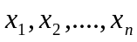 are the values of observations. The population variance is define as
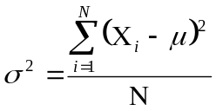
Where:
 is the population variance
X is the value of an observation in the population
 is the arithmetic mean of the population
N is the number of observations in the population

Population Standard deviation: The square root of the population variance is the population standard deviation.
That is we can write according to the definition
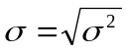

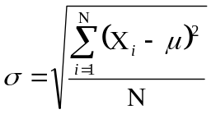

Sample variance: Let are the values of observations in a sample,
Then sample variance is define as
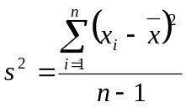

Where:
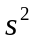 is the sample variance
 is the value of an observation in the sample
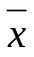 is the mean of the sample
n is the number of observations in the sample.

Sample Standard deviation: The square root of the population variance is the population standard deviation.
That is we can write according to the definition
s =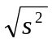
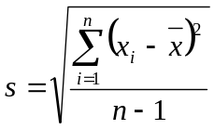

Example: The hourly wages earned by a sample of five students are:
$7, $5, $11, $8, $6.
Find the sample variance and standard deviation.
Sol: 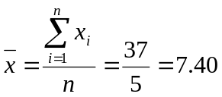
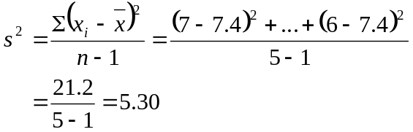

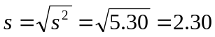.

Sample Standard Deviation for Group Data: Let are the values of observations in a sample and 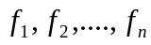 are the class frequencies then SD is defined as

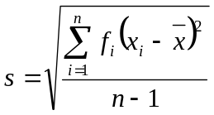; Here 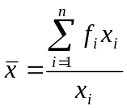

Where:
s is the symbol for the sample standard deviation
is the mid value of the class.
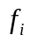 is the class frequency.
n is the number of observations in the sample.
is the mean of the sample

Example: Find Sample Standard Deviation of Group Data

 | 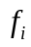
3 | 2
5 | 3
7 | 2
8 | 2
9 | 1

Sol:

 |  | 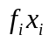 | 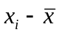 | 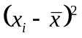 | 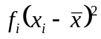
3 | 2 | 6 | -3 | 9 | 18
5 | 3 | 15 | -1 | 1 | 3
7 | 2 | 14 | 1 | 1 | 2
8 | 2 | 16 | 2 | 4 | 8
9 | 1 | 9 | 3 | 9 | 9
Total | 10 | 60 | - | - | 40

We know that,

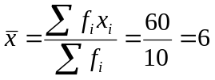

So the sample standard deviation is:

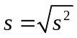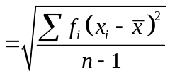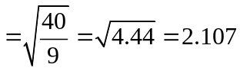

Merits of Standard Deviation:
Among all measures of dispersion Standard Deviation is considered superior because it possesses almost all the requisite characteristics of a good measure of dispersion. It has the following merits:
1) It is rigidly defined.
2) It is based on all the observations of the series and hence it is representative.
3) It is amenable to further algebraic treatment.
4) It is least affected by fluctuations of sampling.
Demerits:
1) It is more affected by extreme items.
2) It cannot be exactly calculated for a distribution with open-ended classes.
3) It is relatively difficult to calculate and understand.

Coefficient of Variation:

The Coefficient of Variation expresses the standard deviation as a percentage of the mean. A coefficient of variation is computed as a ratio of the standard deviation of the distribution to the mean of the same distribution.

It is used in such problems where we want to compare the variability of two or more than two series. That series (or group) for which the coefficient of variation is greater is said to be more variable or less consistent, less uniform or less homogeneous. On the other hand, the series for which Coefficient of variation is less is said to be less variable or more consistent, more uniform or more homogeneous.

The population Coefficient of Variation is
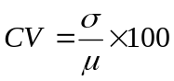

The sample Coefficient of Variation is

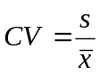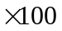

Example: Comments on Children in a community

 | Height | weight
Mean | 40 inch | 10 kg
SD | 5 inch | 2 kg
CV | 12.5 | 20

Sol:
Since the coefficient of variation for weight is greater than that of height, we would tend to conclude that weight has more variability than height in the population.

Skewness: Skewness is the measurement of the lack of symmetry of the distribution. That is when a distribution is not symmetrical it is called a skewed distribution. In a symmetrical distribution the value of mean, median and mode are same. In a skewed these values differ.Skewness tells us about the direction of variation.

In the following distribution the value of mean=median=mode.
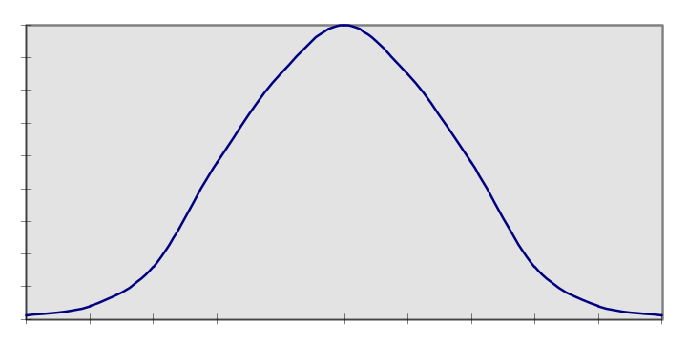

Fig-1: Symmetrical distribution

In the following two curves are not symmetric.

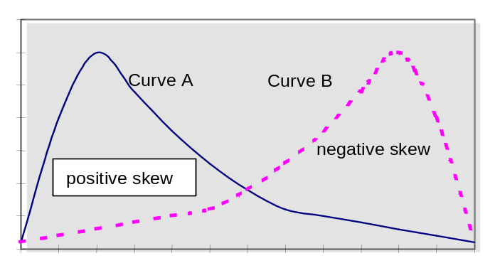

Fig-2: Skewed distribution

Two types of distributions with respect to asymmetry:

1. Positively skewed distribution: In the above fig-2; the curve A is positively skewed distribution. Distribution in which the tail is on the right.

In this case, Mean> Median.

2. Negatively skewed distribution: In the above fig-2; the curve B is negatively skewed distribution. Distribution in which the tail is on the left.

In this case, Median >Mean.

Coefficient of skewness: The method is most frequently used for measuring skewness.The formula for measuring coefficient of skewness is as follows:
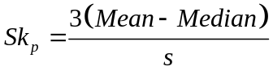
Where;
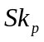=Coefficient of skewness
Mean=sample mean
Median=sample median
s =sample standard deviation.
The range of the coefficient of skewness is lies between -3 to +3.

Problem: From the following data calculate Coefficient of skewness:
15, 18,2,6,4

Sol: We know,

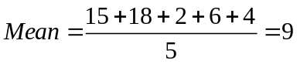

Median=6

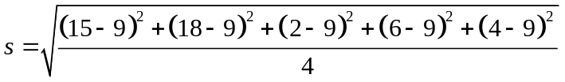
=7.07
Now,
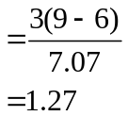
This indicates there is moderate skewness in these data.

Kurtosis: Kurtosis refers the degree of flatness or peaked ness in the region about the mode of a frequency curve. That is, their peaked ness or flatness.
Three types of distributions with respect to kurtosis:

1. Leptokurtic distribution: Peaked distribution or more peaked then symmetric curve.

2. Platykurtic distribution: Flat distribution or less peaked then symmetric curve

3. Mesokurtic distribution: Normal distribution or symmetrical distribution.

Measures of Kurtosis: Kurtosis is measures by
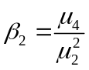
Where, 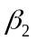=coefficient of kurtosis; 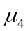=is the 4th moment;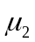=is the 2nd moment
If the values of is greater then 3, the curve is more peaked then symmetric curve that is leptokurtic.
If the values of is less then 3, the curve is less peaked then symmetric curve that is Platykurtic.

Moments: Moments are popularly used to describe the characteristics of a distribution.
It is denoted by.
For ungrouped data:
The rth moment of a variable X about the arithmetic mean is given by:
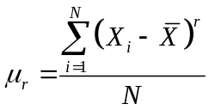;
For different values of r, we shall get different moments.

